**Raising the song**

**呕心沥血的作曲之路**

(英文部分选自经济学人20161119讣告)

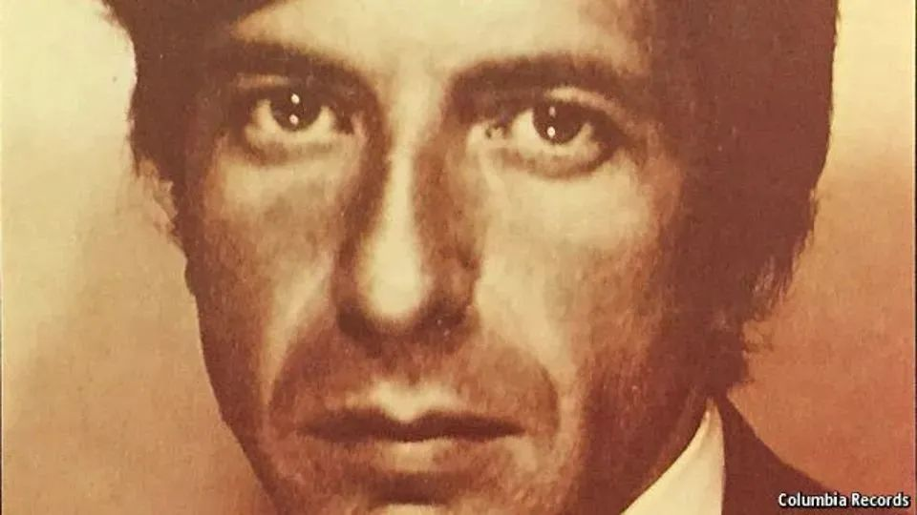

Raising the song

呕心沥血的作曲之路

Obituary: Leonard Cohen died on November 7thThe novelist, **poet and singer was 82**

讣告：小说家、诗人兼歌手莱昂纳德·科恩于2016年11月7日去世，享年82岁

HE HAD little to bring, Leonard Cohen said. **He worked with what he’d got**. Simple chords on his guitar, which he wished he could play better. A finger or two on a keyboard. His “golden voice”, a wry joke (for yes, he often joked, when he could **raise** his brooding eyes **out of** his despair). He was a singer in the lesser choirs, ordained to raise his voice so high and no higher; though certainly low and, after decades of Marlboro Lights, yet lower.

莱昂纳德·科恩说，自己总是轻装上阵，**手边有什么乐器，就用什么演奏**。他用一把吉他就能扫出简单的和弦（还希望自己能够弹得更好），用一两根手指轻敲键盘就能成调。他还拥有一副“金嗓子”；每每从绝望中抬起哀伤的眼睛，他都会插科打诨。他原来在一个小合唱团唱歌，团里要求他把唱歌音调抬到最高。可他本就是低音炮，抽了几十年万宝路之后，嗓音就更低了。

**No ideas filled his songs either, in his view. All he had to offer was his own experience**. Like Bob Dylan, Joan Baez and so many others **in the age of** protest, he sang about democracy, devastation, **a future bleak as a blizzard and an unkind world** in which, **like a bird on the wire, he tried to be free**. But the songs that **welled up** instinctively were about women: Suzanne, who **took** him **down to her place by the river** and fed him tea and oranges that came all the way from China. And you know that she’s half-crazy

but that’s why you want to be there

**在科恩看来，自己写的歌也没有什么想法，有的只是自己的亲身经历**。和鲍勃·迪伦（Bob Dylan）、 琼·贝兹（Joan Baez）等一众反抗时期的歌手一样，科恩歌唱民主，歌唱毁灭，**歌唱那如同暴风雪般暗淡凄凉的未来**，**歌唱人心不古的世界**。在那个世界当中，**他就像困在电线上的鸟儿，怀抱着对自由的渴望，挣扎着**。但受本能所驱，他创作的歌曲都与女人有关。他在歌里写了苏珊娜，这个女子带着科恩来到自己的**河畔小屋**，拿出大老远从中国带来的茶水和橘子款待他。

她自然有些疯疯癫癫

但你却因此执意留在她身边

**Or Marianne, his Norwegian muse, who lit up** **the island of Hydra for four years,**

他的歌或关于玛丽安。她来自挪威，是科恩的缪斯女神。**正是因为这个女子，伊兹拉岛熠熠生辉四年之久【note，把强调的感觉译出来了】**。

I loved you in the morning

our kisses deep and warm

your hair upon the pillow

like a sleepy golden storm

我爱你在每个清晨

我们的吻深刻且温存

你的秀发散落在枕

宛若金色风暴睡意沉沉

but who tried with her fine spider-webs, grey clothespins and gardenias to fasten his ankles to a stone, so that he had to break away:

但她试图用精巧的蛛网、灰色的衣夹和栀子花把科恩的脚踝绑在石头上，所以科恩不得不挣脱：

Well so long, Marianne,

It’s time that we began

To laugh, and cry, and cry, and laugh, about it all again.

玛丽安，我们已走过长路漫漫

是时候再次放声大笑，是时候再次心碎恸哭

眼眸笑意，或清泪两行，都只为我们经历的这一切

With another Suzanne he had a son and a daughter, but domesticity repelled him; he always sang “kitchen” with a snarl. Like a gypsy-boy or a sailor, **he preferred to roam among the world’s wealth of going-down women and unmade hotel beds.**

在生活当中，科恩邂逅了另外一位苏珊娜，并与之育有一双儿女。但他对家庭生活极为反感，唱到“厨房”时，科恩总是几近咆哮。**他就像个吉普赛男孩或水手，更愿意一睹那盛世美颜，徜徉于烟花之地，流连于凌乱的旅馆床榻之间。**

**Singing came late. Words came first**, the charged speech he heard in the synagogue his prosperous family had built in Montreal, sitting in the third row. **The rhythms of the cantor, too, seemed full of light**. Canada, by contrast, clung like a dying animal. He rejected its snow and provincialism though, from time to time, he **drifted back to** Montreal; and he was buried there.

**吟唱在后，词藻在前**。科恩家境殷实，他的家族在蒙特利尔修有一座犹太教教堂。他坐在教堂的第三排，陶醉在慷慨激昂的演讲中。**圣歌的旋律也似乎散发着无尽光辉**。然而，加拿大就像是一头奄奄一息的野兽。虽然反感那里的冰雪与偏狭，但他还是会不时回到蒙特利尔，最终也葬在了那里。

By his mid-30s he had published two novels and four books of poetry, **and knew what it was to pace grey European streets/ in a raincoat /with his head full of Lorca and Joyce**. But he was also starving. Raising his voice brought fame and fortune. There was no hit record, but audiences **in the tens of thousands**, including 600,000 at a hippy festival in 1970 in the Isle of Wight where, like drunken fireflies in the pre-dawn dark, his listeners lit matches at his command. Destiny flared with them. He was paying his rent in the Tower of Song, where 27 angels had long ago tied him down.

在35岁左右时，科恩已出版了两部小说和四本诗集。**他也曾披着雨衣，在灰青色的欧洲大街上漫步，满脑子都是洛尔迦和乔伊斯的诗作**。不过，这时的他还在挨饿。接着，他一展歌喉，名利双收。虽然没有红极一时的唱片，却吸引了数十万听众。在1970年怀特岛的嬉皮士音乐节上，60万听众就像是黎明前的黑暗中醉醺醺的萤火虫，遵从他的指挥，将那一根根火柴点亮。与火柴一同闪耀着的还有命运的火焰。《歌之塔》里的他每天支付房租，但27位天使早就将他捆在桌上。

注释：“He was paying his rent in the Tower of Song, where 27 angels had long ago tied him down.”：本句节选自科恩的作品《歌之塔》，此处直接套用歌词翻译。

David with his harp

大卫和他的竖琴

**Celebrity didn’t charm him, though**. His tastes were modest: elegant, but worn, suits, sometimes a straw palliasse to sleep on. He would sing over café meals to soothe friends. Live performances brought stage-fright so severe that neither speed nor Château Latour, in large doses, could get him through it. **The songs took months, years.** And the **outward show** had less and less meaning. Since his youth he had been seeking a vision of God and a master who could take him there, out of the uselessness and ruins of himself. His “Book of Mercy” of 1984, heavily based on the Psalms, showed him trying to sing out of la région sauvage. He wanted to **raise up** his song **to** the Lord as David did on the harp, though still damp from the body of Bathsheba, with nothing on his tongue but “Hallelujah!” And for that, la route lay inward.

**然而，科恩却视名利如粪土**。他品味节制，身着老旧又不失优雅的套装，有时候就睡在稻草褥上。为了安慰朋友，他会在喝咖啡时为友人放声歌唱。他对现场表演心怀恐惧，无论是大剂量的甲基苯丙胺，还是大口的拉度酒庄，都不能帮他克服这种恐惧。**创作歌曲往往耗费几个月，甚至几年的时间，**登台表演的意义也越来越小了。从青年时起，科恩就在寻找神示，寻找一个能带他找到神示的大师，带他逃离无用而颓废的自我。1984年，他在《诗篇》的基础上创作了《宽恕之书》，书中的他要把歌声传到荒原之外。他想让自己的歌声传到上帝的耳里，除了“哈利路亚！”之外再无其他声音，就像大卫一样，尽管迷恋拔示巴沐浴时的身体，依然通过弹奏竖琴感动上帝。为此，他在心中铺平了道路。

注释：《诗篇》（The Psalms）：一部由真正敬奉上帝的古代以色列人撰写的赞颂、信赖和祷告上帝的诗歌选。是基督教重要的诗歌类文献。speed：俚语，指中枢神经兴奋剂甲基苯丙胺，是冰毒的有效成分。Chateau Latour：拉度酒庄，位于法国波尔多，同名品牌的葡萄酒为世界顶尖。大卫弹奏竖琴和迷恋拔示巴沐浴的故事详见《圣经·旧约·撒母耳记》。

Judaism was his home, but he freely stole from others. He sought alternative cures. The tormented Catholic Christ hung in his songs and bled there, like himself. From 1993-98 his need for silence drew him to Zen, to a monk’s life in a shack (with essential espresso machine) 6,500 feet up a mountain in California. There he wrote, smoked, shovelled snow, romped in his dreams with an immense cloudy woman, and came down, back to Boogie Street, **convinced he had no gift for spiritual matters.**

犹太教是他的精神家园，但科恩也自由地从其他宗教中吸取营养。他探索着其他的救赎之道。在他的歌里，天主教基督像他自己一样被挂在十字架上流血，饱受折磨。1993-1998年间，他想要保持沉默，于是皈依禅宗，带上必不可少的咖啡机去了加利福尼亚的高山上，到海拔6500英尺的地方搭了间棚屋生活。他就在那里过上了和尚般的清修生活，写作、抽烟、铲雪，在梦中和巨大的云姑娘嬉戏喧闹。后来，他下山创作了《布吉街》，确信自己并无慧根。

The songs, when he returned to them, said otherwise. His concerts became more like **prayer gatherings**: in 2013, when he went out on the stage of the world one last time, he was dropping to his knees to sing. He was still **railing at** God and growling at the apparent randomness of everything: **if God was the dealer, he was out of the game**. Yet he was also calm. He might be old, but he was still fine-looking, natty in his grey fedora. And he was not afraid of what was coming. This summer, he assured the far-away dying Marianne that if she stretched out her hand, she could reach his; he was just behind her on the road. He had learned, with Abraham, to sing “Here am I”; he had learned too to accept that his true song, his great song, could never be perfect, for there was a crack in everything; that’s how the light got in.

他的音乐会更像是**祷告集会**：2013年，他最后一次站在世界大舞台上，演唱时双膝跪地。他仍对上帝怀有怨念，因万物混乱无序而大声怒吼：**如果上帝是发牌者，那他便已出局**。然而，科恩也能保持平静。也许他已年老，但他戴着整洁时髦的灰色软呢帽时依然相貌堂堂。他对即将到来的命运也毫不畏惧。这个夏天，他安慰在远方即将辞世的玛丽安，告诉她如果她伸出手，便能碰到他的手，因为他将紧随其后，与她共赴黄泉。他学会了和亚伯拉罕一样，唱出“我在这里”；他也学着接受自己最看重的歌——也是他最伟大的歌——永远不可能完美。因为万物皆有缝隙，而阳光正是从缝隙间照进来。注：亚伯拉罕是上帝的忠诚信徒，有关上帝测试亚伯拉罕的忠诚的内容，请参见《圣经·新约·雅各书》。

May everyone live

and may everyone die

Hello my love,

and my love, Goodbye.

愿人人活得其乐

愿人人死得其所

亲爱的，

亲爱的，

我们一别待相会。